

Life Skills 100

The Boxes of Life

"Life is like a box of Chocolates…", from Forrest Gump, Tom Hanks

Life is made up of boxes, they can be broken into weeks, months or years, you move through life moving from box to box and there can be many boxes in your life, so you may be in a particularly bad way emotionally, financially or otherwise and you need to say to yourself, what or where will I be in one month's time, what or where will I be in three month's time, what or where will I be in one year's time, which box will I next be in…because you need to be aware that there are more boxes ahead. So move on!

Here is a sample of life's boxes

Box 1 Age 1 to 6 You will not remember much about this box but to know you are the most important person in the world. You learn about reliance, loving etc.

Box 2 Age 7 - 11 Primary School
You suddenly learn you are not the centre of the universe and need to deal with getting on with kids and having some organisation in your life, you will start to get feelings and realise that life is a sharing thing.
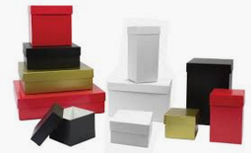

Boxes Galore, Age 12- 17 High School Here you discover emotions and bullying and friendships and your academic ability, depending on your education you might determine your future career, meet you first life long friend (remember you will only have about 3 or 4 actual life long friends that you can call on when you are in desperate need), so look after your friendships. You might be introduced to sex, drugs and alcohol and how you deal with these will move the boxes you live in around.

More Boxes Age 18 -23 University, College, a job or just loafing around will take you to a choice of several boxes, so here is a very important time in your life the average person falls in love two or three times, so there may be some emotional times and time to recall what you will be doing in 1 month, 3 months or 2 years time?
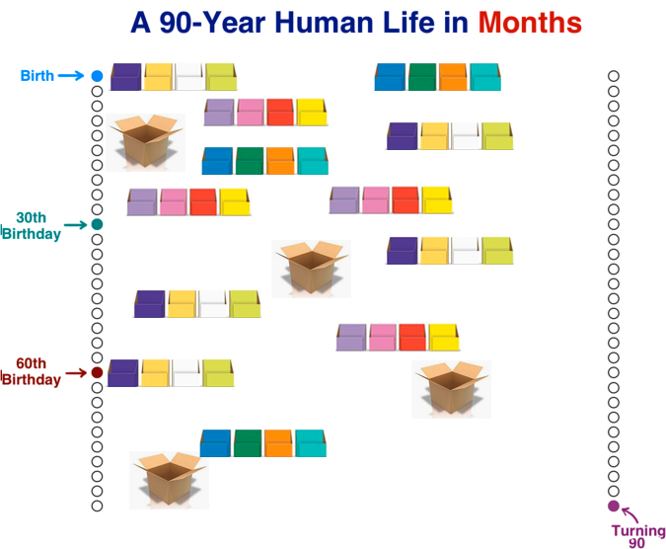So this is life moving from box to box, you may find you are in a job where the brainless idiot is your boss and you might need to plan a move to another box with a different employment opportunity, the choices are yours, so choose your boxes well but remember if this is not the right moment for you or the right direction more boxes are ahead and waiting for you… so move on.

Frame every so-called disaster with these words: “In five years, will this matter”?

13 11 14

Lifeline Australia

The core Life Skills as laid down by WHO are:

There are many such skills, but core life skills include the ability to:
- Self-awareness.
- Empathy.
- Critical thinking.
- Creative thinking.
- Decision making.
- Problem Solving.
- Effective communication.
- Interpersonal relationship.

The Ten core Life Skills as laid down by you (add your own)

Think and learn to think, think when you speak, and think when you do anything.
Learn to perform good in your world, be professional in everything that you do.
Wherever you go never forget your parents or friends. Call them often and stay connected, tell someone where you are going.
Take the opportunity and travel as much as you can whether for work or for fun, life's experiences come from seeing and meeting interesting people and visiting new places.
Learn to cook enough to feed your self, start with easy things then try more interesting menus.
Read and learn from others experiences and learn more, read a good range of books and have a joke book as your table book to brighten up your day.
(https://www.penguin.com.au/books/man-walks-into-a-bar-9781446406427)
Learn to be responsible for yourself look after your belongings and especially your health everything depends on you and you only.
Learn to enjoy everything that you do if you fail at least you tried, but learn from your failings, learn fail then learn again.
Learn to ignore the small things and concentrate on the big picture, you will be much happier if you don't let trivialities get you down.

Smile look in a mirror and smile and stay positive and happy.

